|  |  |  |
| --- | --- | --- |
| **CSC 310 Human Computer Interaction**  **Heuristic Evaluation Report Template**  **Dated**  **11/18/2021**   |  | | --- | | **Prepared By:**  **GROUP NAME: New Space Old Jam Come on and Slam**  **CONTRIBUTOR(S): Brent Vespa, Nicholas Crumb, Noah Helzerman** |  |  | | --- | | **Evaluation Of:**  **Name of system being evaluated: Digikey**  **Group that created the system being evaluated: LCZ** | |

## 

|  |  |
| --- | --- |
| Feedback & Critical Incidence | << Record your observations in the table on the following page, based on your observations and notes taken during the evaluation.  Description of columns in the table are as follows:  *Prototype Screen/Page:*  Which screen of the user interface was being tested at the point of feedback/critical incidence/problem.  *Name of Heuristic:*  Which of the 9 heuristics is being referenced. Enter the full name of the heuristic. Refer to the heuristic evaluation lecture slides for the 9 design principles.  *Reason for negative feedback / breakdown:*  Explain the reasons why the interface violates this heuristic. Be sure to be clear about *where* in the screen you are referencing.  *Scope:*  Describe the scope of the feedback or the problem; include whether the scope of the issue is throughout the product or within a specific screen or screens. If the problems are specific to a page, include the appropriate page numbers.  *Severity (H/M/L) :*  Your assessment as to whether the implication of the feedback is *low*, *medium*, or *high* severity, and a justification for why you are giving it that rating.    *Way(s) to rectify and Tradeoffs (i.e., why the fix might not work):*  Suggestion for the modifications that might be made to the user interface to address the issue or issues in this row. You MUST include trade-offs to be credible. If you can’t think of some bad trade-off, say so.  *Action taken and Justification:*  DO NOT FILL IN THIS COLUMN. This will be filled in by the person who created the system being evaluated, to say what he did with respect to the recommendations you make. |

| **#** | **Prototype Screen** | **Name of Heuristic** | **Reason for negative feedback / breakdown** | **Scope** | **Severity**  (High/ Medium/ Low) and **Justification** for giving it that rating | **Way(s) to rectify and any Tradeoffs** (i.e., why the fix might not work) | **Action taken and Justification (*to by filled in later by the person who created the system being evaluated*)** |
| --- | --- | --- | --- | --- | --- | --- | --- |
| 1 | See Picture 1 | 7. Provide Shortcuts  6. Provide Clearly Marked Exits | Upon searching for a part, you have to click on the listing in the table to see its image, however there is no way to go back to the table without redoing the search and trying to find where you were at. | Search screen and Item Screen | High, if left unchecked will cause a lot of user confusion and might lead to users quitting the software due to constant time losses. | Included a back button, somewhere on the page, as this issue extends to every part selected. | Added a back button as requested  The back button is a decent quality of life concern – but not deal breaking – since most websites have built in back buttons in their browsers – since this would be a website. |
| 2 | See Picture 2 | 8. Deal with Errors | Upon selecting Cart, you are allowed to procced to checkout, even if you have no items in your cart. In addition, you can even proceed past the card information without entering anything.  You can also insert large numbers, 0, or negative numbers as your item quantity. | Cart Screen | High, if left unchecked can cause people to be able to order items without paying and setting for items to be delivered without a delivery location. | Included a check that scans the content of the Cart and Credit Card information pages to make sure they are valid.  For minimum values of 1, and maximum values based on item’s current stock  Get absolute values to avoid negative inputs | Added checks for the proper value for the product details page and the cart page  Whoops! Good catch. This would of broken many of the supporting systems if we left that bug in there. |
| 3 | See Picture 3 | 1. Simple and Natural Dialog | Upon resizing the application, there is no way to scroll up, down, left, or right. Thus, if you tried to have two applications side by side, the system would be mostly unusable. | All pages | Medium, while this won’t affect all users, those that it does effect will cripple their user experience. | Add a scrolling bar and feature when the screen size is changed. | Added Scrollbars  I don’t see this happening very often. But it’s not a bad idea. |
| 4 | See Picture 4 | 1. Simple and Natural Dialog | The label row describing the elements of each column appears to be duplicated. | Search Screen | Low  Justification:  It’s just redundant info that shouldn’t lead to much confusion. | Remove the extra row. | Removed the extra row  This looked highly unprofessional with that first row duplicated. |
| 5 | See Picture 5 | 4. Be Consistent | The “Your Contact Information” Header appears to be another entry field. | Shipping/Address Screen | Medium  Justification:  User’s may think that one of the entry fields is missing or combined with the left-hand side. | convert the headers and sub headers into the ones found on the Search page (Products, Filters, and Results, for example) | Removed the contact information row  This would have been confusing to the user if that contact information row remained in there. Good idea. |
| 6 | See Picture 6 | Deal with errors in a positive manner | The interface allows users to change the text in the left column of the checkout screen. | Issue is specific to the checkout screen. | Medium – this defect could be confusing for users and could result in a frustrating experience and errors. | Make the text in the left column immutable. | Made the column on the left of the address menu read only  This was a big UI bug. Good catch |
| 7 | See Picture 7 | Be consistent | Only 3 shipping methods utilize the “Estimated” column. The rest of the shipping methods include their estimated delivery time in the “Shipping Method” column. | Issue is specific to the shipping method screen. | Low – despite the inconsistency, it’s still pretty clear how long each shipping method takes. | Use “Estimated” column for each shipping method. | Added an estimated time for each shipping method.  This wasn’t that big of an issue since the description of the shipping method was self explanatory. |
| 8 | See Picture 8 | Provide feedback | After selecting a shipping method and clicking “Apply Changes”, nothing happens | Issue is specific to the shipping method screen. | High – it is currently not clear if the “Apply Changes” button is broken, not yet implemented, or performing some work in the background without notifying the user. | Give some indication to the user that the button is performing a task or failing. | Added a notification text  This is a good house cleaning issue that needed to be addressed |
| 9 | See Picture 9 | Minimize user’s memory load | The “Search” buttons on the main page turn into search bars when clicked on, but never turn back. This requires users to remember that the white boxes on the main page are search bars. | Issue is specific to the shipping method screen. | Low – Could be frustrating for the user if they forget about the search bars. | Include hint text within the search bars that indicate they are search bars. | I disagree with this criticism. It has the same text as the search bar on top. Intuitively a user would should know that a box with a search text in it would be a small search bar. |
| 10 | See Picture 10 | Deal with errors in a positive manner / Speak the user’s language | The items in the “Manufacturer”, “Series”, and “Packaging” fields in the filter results screen are cut off because the windows are too small. | Issue is specific to the filter results screen. | Medium – User is unable to view the full text without hovering the cursor over each individual item. This slows down the user experience. | Expand filter windows to fit the text within them, or add scroll bars. | Added horizontal scroll bars  Good catch. That would have been frustrating to no be able to read the whole label |
| 11 | See Picture 11 | Be consistent / Speak the user’s language | The filter results can be sorted in either “Price Ascending” or “Price Descending” order. This is inconsistent with other online stores that typically sort in “Price High to Low” or “Price Low to High” order. | Issue is specific to the filter results screen. | Low – The meaning of the buttons is still clear, despite the inconsistency. | Consider changing the verbiage of the buttons. | Relabled the sorting buttons.  This is a reasonable idea |

Picture 1:

Picture 2:

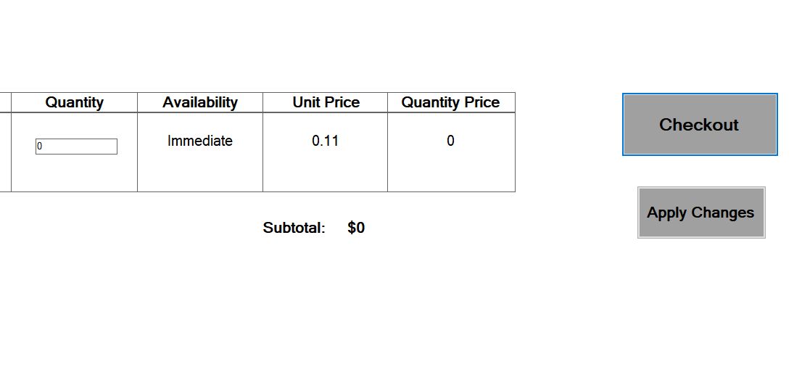

Picture 3:

Picture 4:

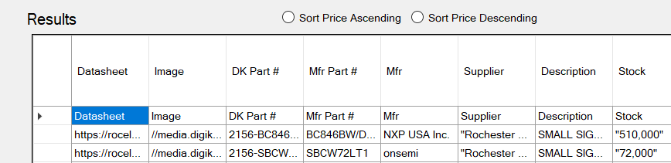

Picture 5:

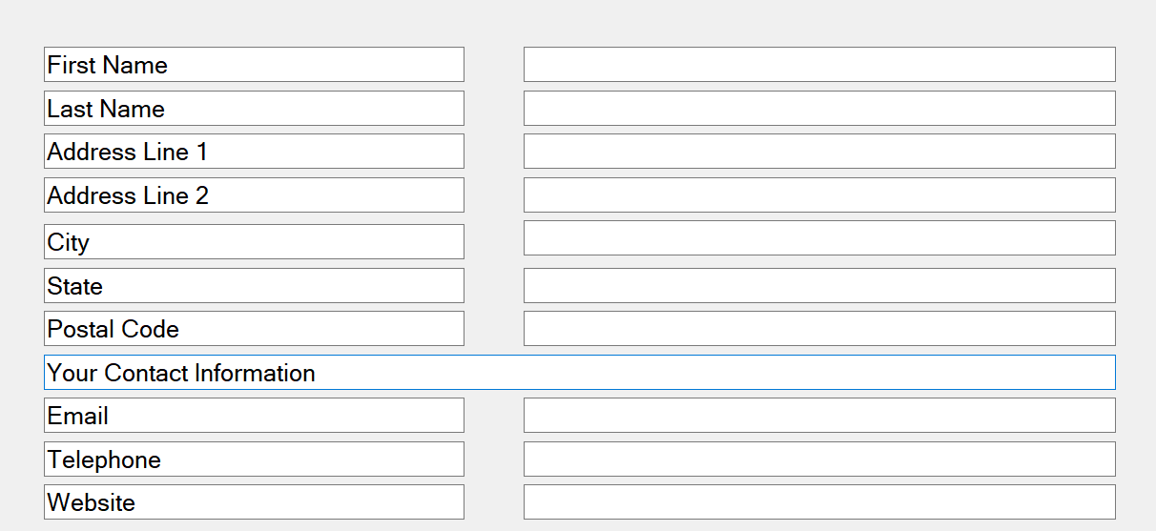

Picture 6:

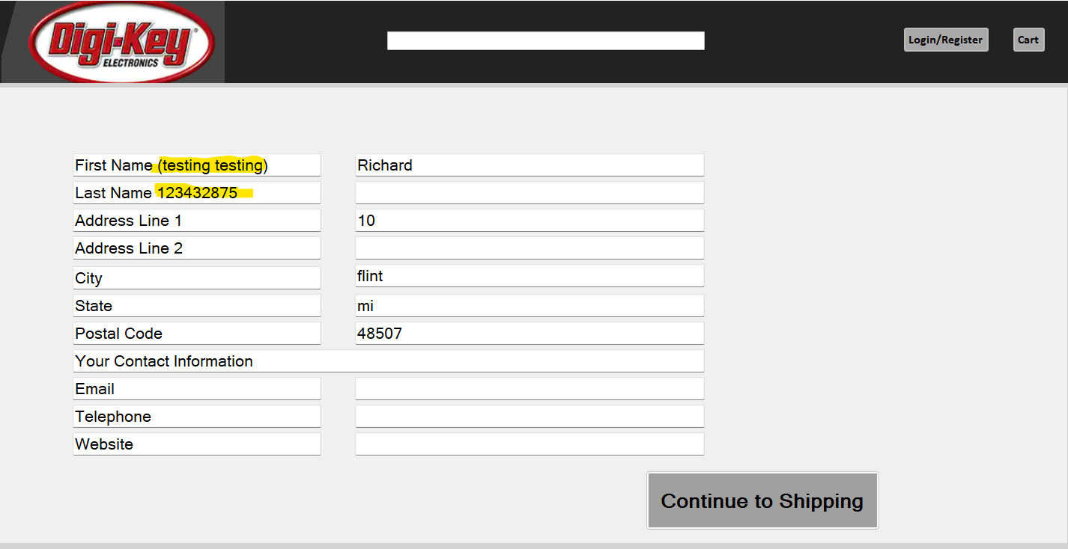

Picture 7:

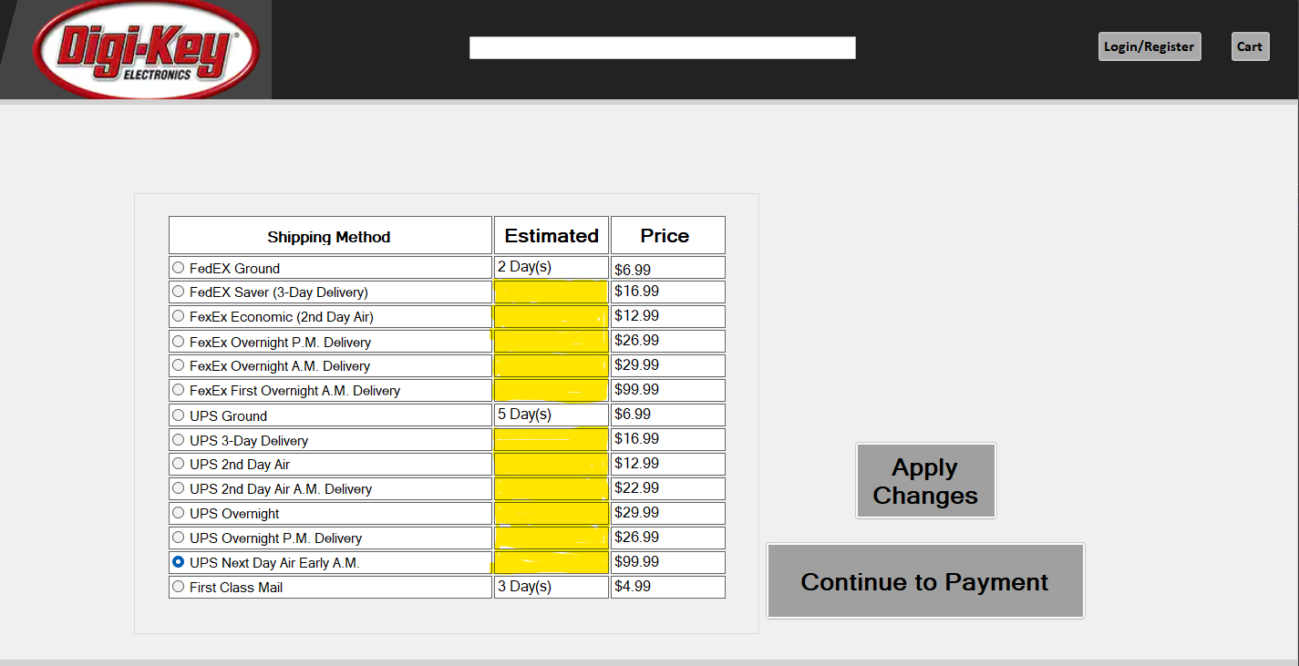

Picture 8:

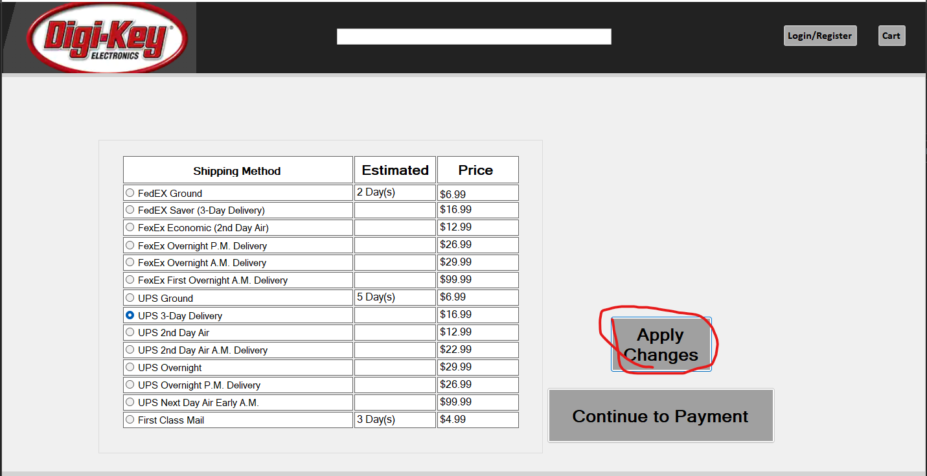

Picture 9:

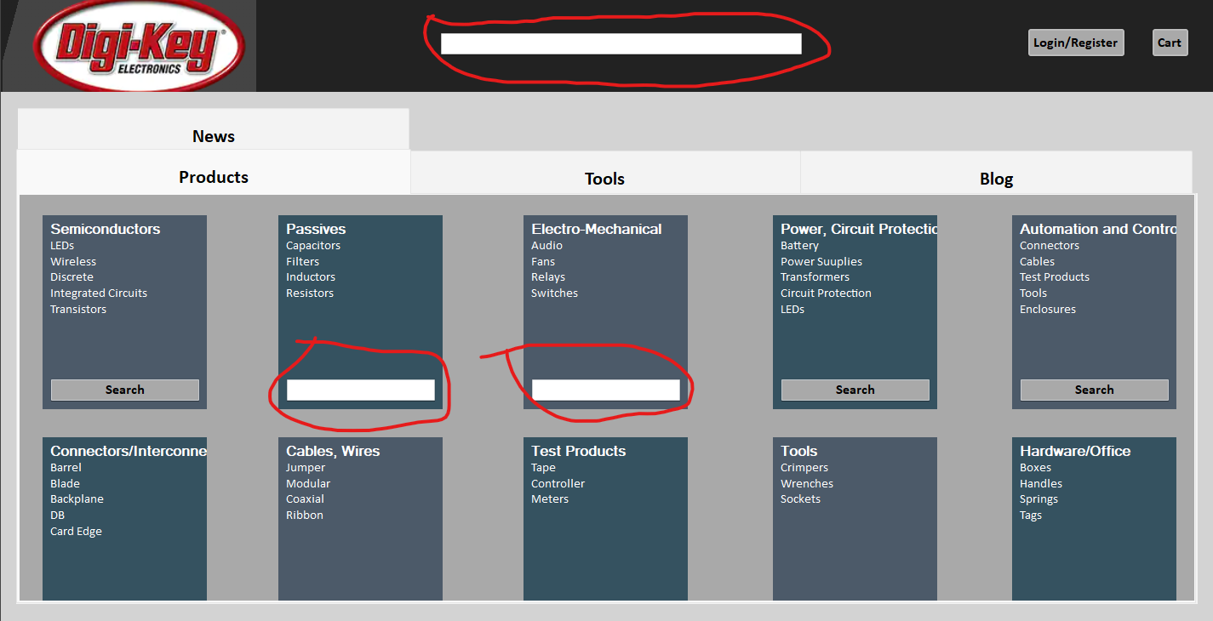

Picture 10:

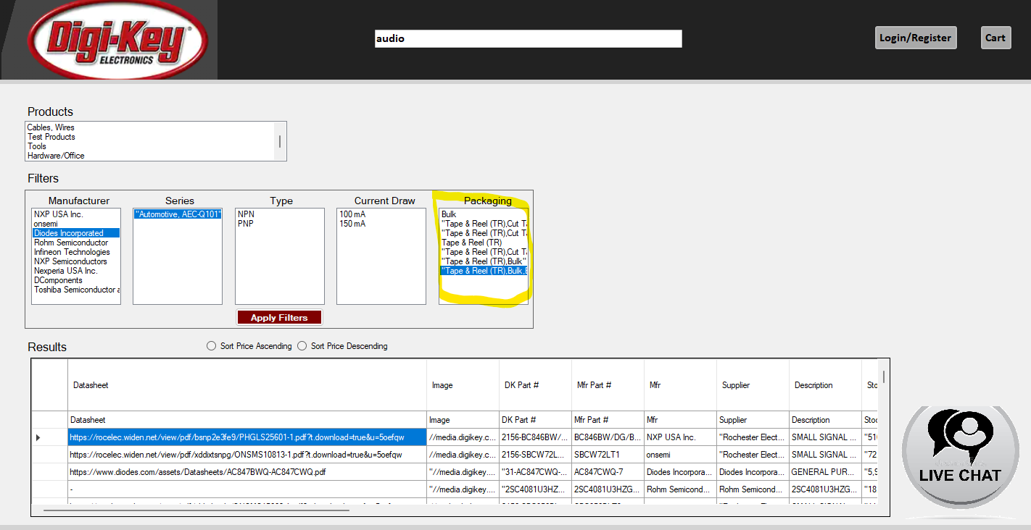

Picture 11:

